



**DONE BY PRANAV AJAY**

**CLASS-12A**

**ADM NO-A03674**

**SCHOOL-ICSK SENIOR**

**HUMAN CLONING-ANOTHER YOU?**

BIOLOGY INVESTIGATORY PROJECT

**THE INDIAN COMMUNITY SCHOOL KUWAIT**

**(DEPARTMENT OF BIOLOGY)**

**BONAFIDE CERTIFICATE**

CERTIFIED TO BE THE BONAFIDE PROJECT OF WORK DONE BY

MR.__Pranav Ajay_________________________ OF CLASS__XII___ SECTION__A_____ IN THE INDIAN COMMUNITY SCHOOL KUWAIT DURING THE YEAR ____2022-2023_____

DATED ______________ INTERNAL EXAMINER

THE INDIAN COMMUNITY SCHOOL, KUWAIT

**SUBMITTED FOR ALL INDIA SENIOR SCHOOL CERTIFICATE**

EXAMINATION IN BIOLOGY AT THE INDIAN COMMUNITY SCHOOL, KUWAIT

DATE______________ EXTERNAL EXAMINER -­­______________

**DECLARATION**

I hereby declare that

I Pranav Ajay created this biology investigatory project entitled ‘Human cloning-Another you?’with my own efforts and with the guidance of my biology teacher

Mrs. Nigy Jacob and my parents and friends

**ACKNOWLEDGEMENT**

With a joy of accomplishment, having completed this work in, I wish to record my sentiments of gratitude and appreciation to my teacher, Mrs. Nigy Jacob, whose guidance and sustained interest has seen the completion of this project. I am also indebted to my parents, Principal Sir, Teachers and friends and well-wishers who have directly and indirectly helped me see this task the light of day. I am grateful to them for their encouragement and constant support.

**INDEX**

|  |  |  |
| --- | --- | --- |
| **S.no** | **TOPIC** | **PG.NO** |
| **1** | **INTRODUCTION** | **6** |
| **2** | **HUMAN CLONING** | **10** |
| **3** | **THE PROCESS** | **12** |
| **4** | **BENEFIITS AND PROBLEMS** | **16** |
| **5** | **CONCLUSION** | **18** |
| **6** | **BIBLIOGRAPHY** | **19** |

**INTRODUCTION**

The word “Clone” means, “Identical”,

identical in all aspects. In biological point of view, two or more organisms are said to be clones of each other if they are morphologically, anatomically and more important,genetically identical. Clones have identical genome. Since the protein synthesis and metabolism is controlled by an organism’s genome,clones are

identical in all aspects. Cloning is done by nature in many lower level organisms like Monerans, Fungi , and in some eukaryotes.Cloning can be clearly

observed during reproduction of these

organisms by a process called “binary fission” in which a single cell grows and divides into two identical daughter cells. They are Clones. This can also be observed during “multiple fission” in some protozoans like *plasmodium*.

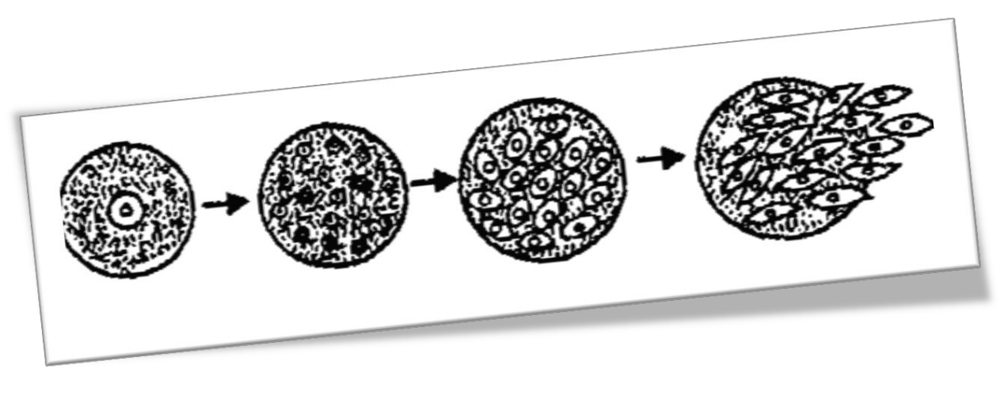

Cloning can be done artificially to produce

genetically identical organisms. Several methods have been developed to clone an organism.The most applied method is “Somatic Cell Nuclear Transfer (SCNT)”. This method has been widely used to produce a large number of identical organisms. The first fully cloned animal was a sheep named Dolly. It was clone by SCNT technology. In Somatic Cell Nuclear Transfer, an egg from a female is taken and its nucleus is taken out and is disposed. Then, a cell from the body of same organism is taken; it must a cell other than the reproductive cells. Any body cell other than the reproductive cell is called a Somatic Cell. The nucleus of this somatic cell is taken out carefully and it is inserted into the previously ‘enucleated’ cell. It is not just insertion; it is fused with the hollow egg using electricity. This fools the egg that is has been fertilized. Lets make this clear with an example. Suppose we want to clone a cow

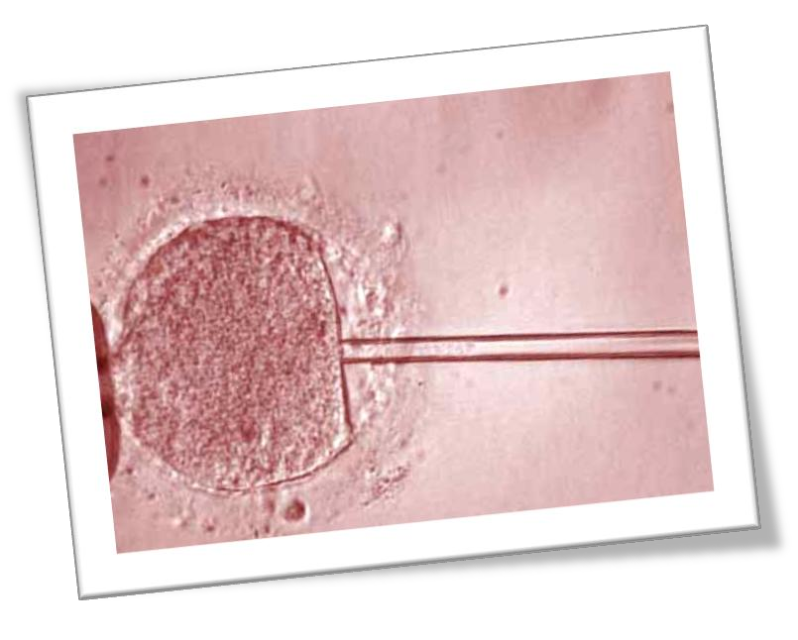

named ‘A’. We will first request the cow to

donate an egg. Since this has donated us an egg, it is called a ‘Donor’. Now that we’ve the egg, we will carefully suck out the nucleus from it and keep the‘enucleated cell’ safely. After that, we will again go to the donor cow and take a cell from some other body part. These cells are diploid. Again pull out the nucleus and this time keep the nucleus safe. Now, carefully insert this nucleus into the previously enucleated cell and apply an electric current of suitable voltage. That’s it! If we’ve done everything perfectly, the egg (which now pretends to be a zygote) should develop into an embryo and slowly into a cow which is clone of the donor cow! Look at this picture, it describes the SCNT

technology. This is how Dolly was cloned

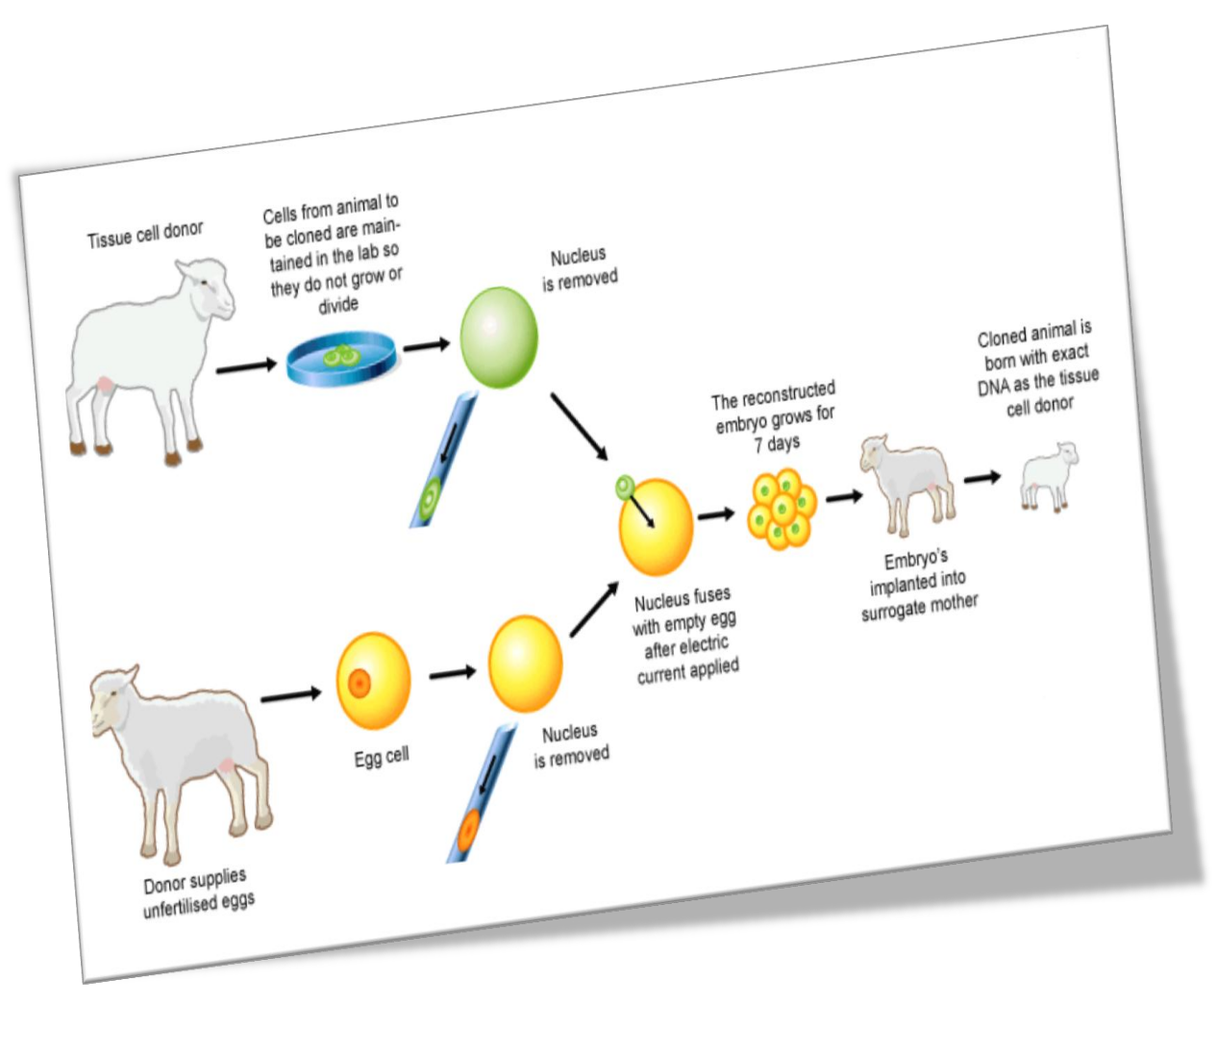

**HUMAN CLONING**

Scientists have managed to clone a number

of animals like sheep, cow, mice etc. But, their dream of cloning a human remained unfulfilled. There have been many attempts of cloning a human. It has become more of an ethical and social issue rather than a scientific advancement. Many scientists claimed that they have cloned a human. In 2004, a South-Korean scientist and his team claimed that they have successfully cloned 11 human embryos for the purpose of extracting stem cells; later it was confirmed that it was a false statement.

Scientists say that is in fact possible to clone a human by using the famous SCNT.A cell, which contains DNA, is taken from the person who is being cloned. Then the enucleated egg is fused together with the cloning subject's cell using electricity. This creates an embryo, which is implanted into a surrogate mother through in

vitro fertilization**.**If the procedure is successful, then the surrogate mother will 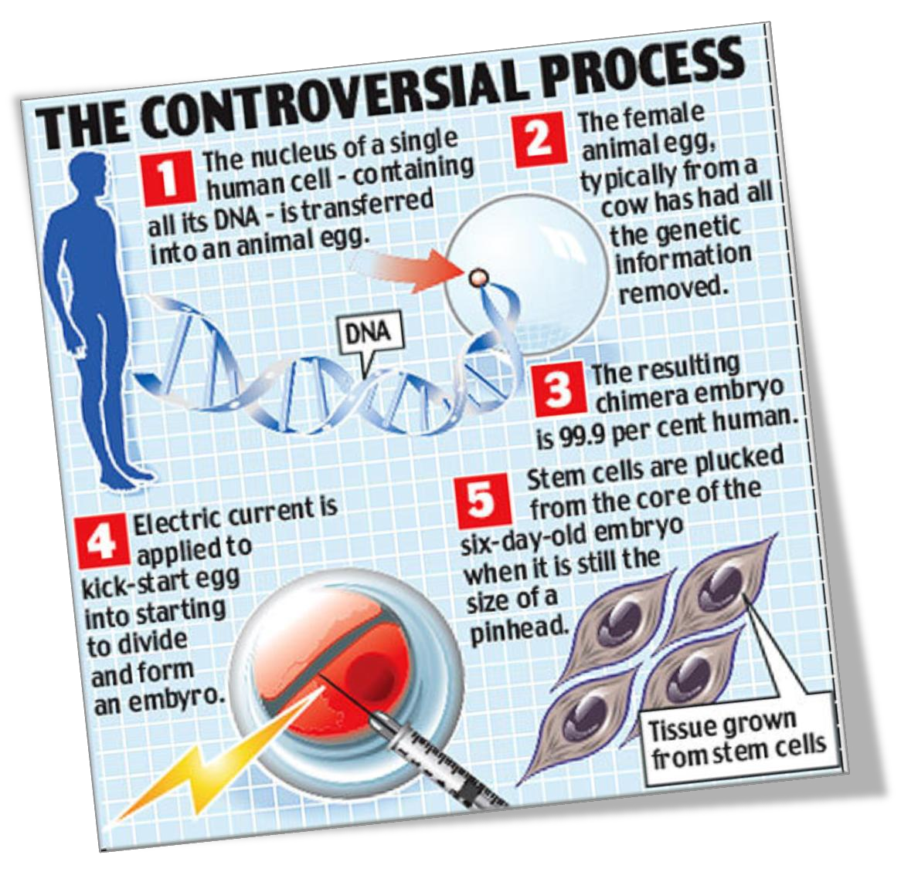give birth to a baby that's a clone of the cloning subject at the end of a normal gestation period. Success rate is

estimated to be about 2%. Here’s a picture:

**THE PROCESS**

Now, here are the steps involved in cloning a human in a brief way. The actual process is far more complex than what the steps here depict.

**Step One:**

The first step is yo fetch an unfertilized alive human egg. Scientists get them from the egg banks where the eggs are stored safely in an extremely cold environment, perhaps about -196 degree Celsius.

**Step Two:**

The next step is to obtain any body cell other that the reproductive cells from the individual to be cloned. These cells are called Somatic cells. They are preferably obtained from soft tissues of the body where the cells are active and young.

**Step Three:**

After getting the somatic cell, the next step is to extract its nucleus carefully. After the nucleus is extracted, the remaining part of the cell is thrown away and the nucleus is kept safe for the following process.

**Step Four:**

Now we take the egg again and extract its

nucleus. This time, we throw the nucleus away and keep the hollow cell with us. Yes! Throw the nucleus away. Only the enucleated cell is going to be part of the process.

**Step Five:**

Now we have all the raw material for the cloning process. In this step, the nucleus extracted from the somatic cell is carefully injected into the enucleated egg. This looks like a brand new cell! But the process will be incomplete without the next step.

**Step Six:**

To make the cell actually work, the cell has to be activated by using an electric spark. Then the nucleus fuses with the cell and forms a kind of pseudo zygote. This is the last step of the human cloning. Since we have produced a zygote, the rest of the process follows the regular steps like embryogenesis etc. Further development of the zygote needs it to be implanted into the uterus of a surrogate mother. After complete growth, the individual will be an exact clone of the person from whom the somatic cell was extracted.The process seems so easy reading these six steps. But it is in fact extremely complex and the chance of successful development of the cloned zygote into an embryo and then into a fully grown individual is very small. Many attempts have been made to clone human. Some of them succeeded in producing the cloned zygote and even went up to the embryo development. But the process ended there.

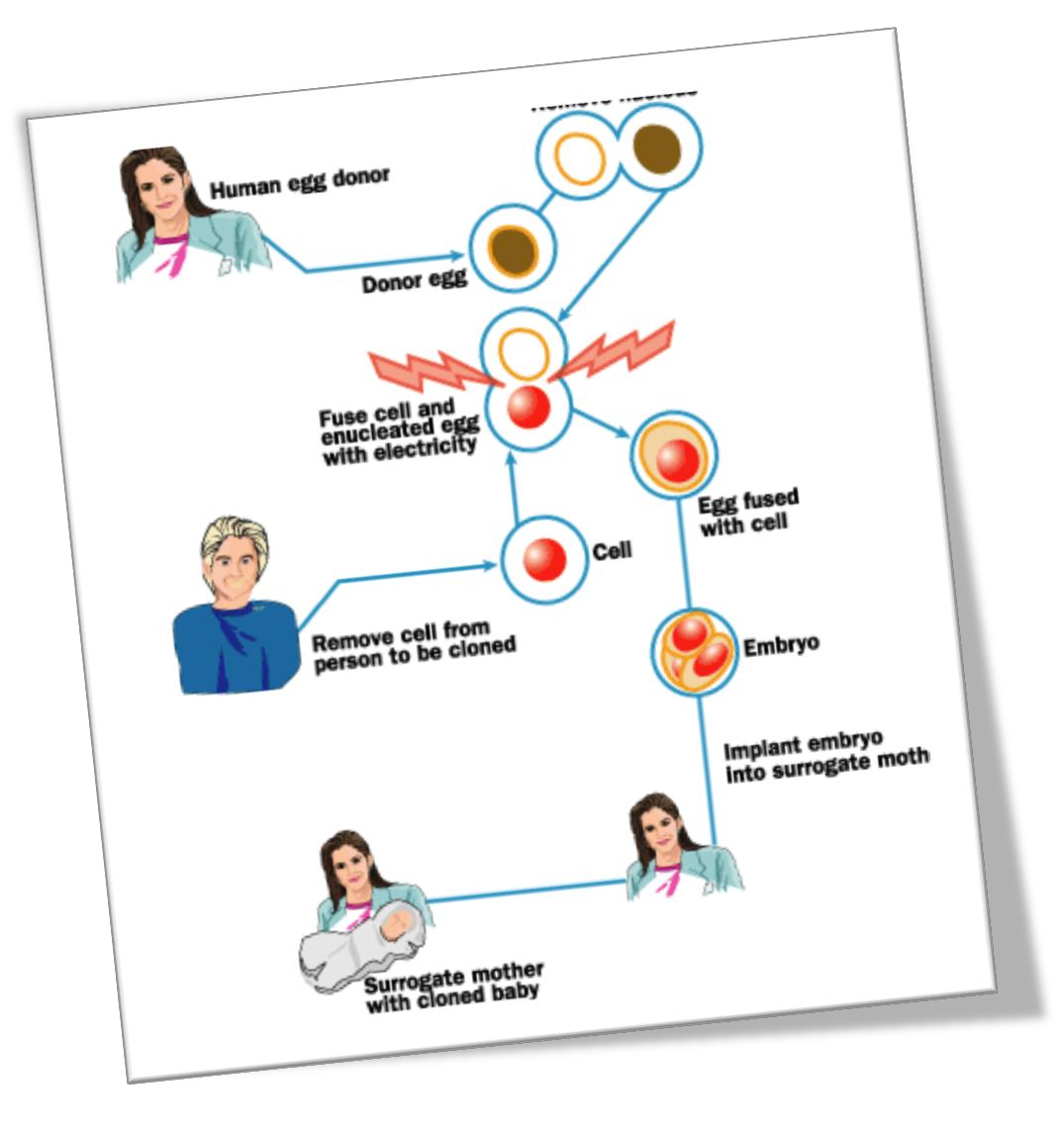**BENEFITS AND PROBLEMS**

Many scientists believe that the process of

cloning a human could be very advantageous:

Some hope to create a fertility treatment that allows parents who are both infertile to have children with at least some of their DNA in their offspring. While others suggest that human cloning might avoid the human aging process. One of the considered options to repair the cell

depletion related to cellular senescence is to grow replacement tissues from stem cells harvested from a cloned embryo.

There are also as many problems regarding this technology:

This is and extremely expensive

process and cannot be produced easily. The

success rate of producing a cloned human is extremely low.Also because of various ethical reasons many people still are reluctant to accept this new form of technology

The below statistics show how morally acceptable is human cloning in the USA

as years pass by

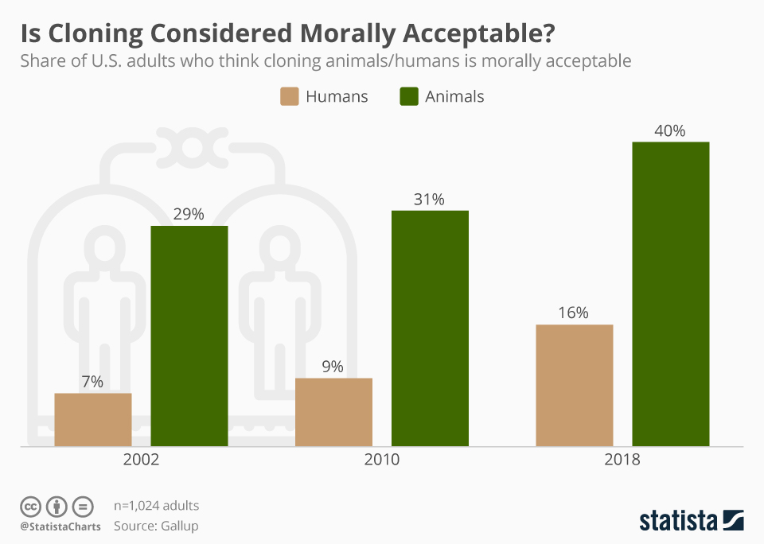

**CONCLUSION**

So, cloning a human is actually possible and this experiment has been done many times all over the world by many organizations. There are also many laws implemented regarding this controversial process in almost all the countries. There are only a few countries where human cloning is not completely banned. United States is one of them. It has no strict rules that ban this technology. This debate continues forever and some day, some scientist will definitely make his own clone and prove that human cloning is reality.

BIBLIOGRAPHY

Wikipedia.com

HowStuffworks.com

Scirus.com

StumbleUpon.com